



**Location Studio** Qt Automotive Suite   
Runtime Environment Setup



June 2017

**Revision Sheet**

|  |  |  |
| --- | --- | --- |
| **Release No.** | **Date** | **Revision Description** |
| Rev. 0 | 6/13/17 | Initial Draft |
|  |  |  |
|  |  |  |
|  |  |  |
|  |  |  |
|  |  |  |
|  |  |  |

**TABLE OF CONTENTS**

GENERAL INFORMATION 1

Purpose 1

Linux Hardware and Software Requirements 1

Setting Up Environment for Ubuntu x86-64 2

Install Ubuntu-16.04.1 LTS 2

Download the project 2

Run the install script 2

Release Package Contents 3

/bin 3

/docs 3

/library 3

/samples 3

install_automotive.sh 3

Create Your Location Studio Developer Account and API Key 4

Create Your Developer Account 4

Add an Application 4

Create the API Key 5

Enter your API key into the QML Configuration Files 5

Run the Demo 6

# GENERAL INFORMATION

## Purpose

The purpose of this document is to provide the detailed information about the hardware and software environment settings and configurations needed to successfully load and run the Location Studio Automotive Reference application on the Linux platform for x86 -64 hardware environment.

## Linux Hardware and Software Requirements

| Name | Vendor, Model and Serial # |
| --- | --- |
| Device | VMware player(>=6.0) or x86-64 motherboard |
| Operating System | Ubuntu 16.04.01 LTS, x86, 64bit |
| QT Version | 5.8.0 |
| Dependency Libraries | libgbm1, libegl1-mesa, libegl1-mesa-drivers, libgles2-mesa, libgles2-mesa-dev, libgl1-mesa-dri, libasound2-dev, alsa-oss, libphonon-dev, libwayland-client0, libwayland-server0, libsqlite3-dev, libfreetype6-dev, libgstreamer1.0-dev, libwayland-dev, libwayland-egl1-mesa*, libgstreamer1.0-0, libssl-dev, libarchive-dev, libyaml-dev, libfontconfig1-dev, libdbus-1-dev, libdbus-1-3, libdbus-glib-1-dev |

# Setting Up Environment for Ubuntu x86-64

## Install Ubuntu-16.04.1 LTS

Please follow the link below to download the image of ubuntu 16.04.1 LTS x86 64bit

PATH: <http://releases.ubuntu.com/12.04/ubuntu-12.04.4-desktop-i386.iso>

This image can be either installed on Virtual Machine or actual x86-64 hardware platform.

## Download the project

Download the project from git.location.studio by either cloning it or downloading a zip file and uncompressing it.You may need to create an account on git.location.studio if you don’t already have one.

## Run the install script

$ sh install_automotive.sh all

Will install all dependency libraries, Qt5.8.0 with Automotive Suite, LocationStudio Qt Plugins and resources.

$ sh install_automotive.sh

Will install Qt5.8.0 with Automotive Suite, LocationStudio Qt Plugins and resources without the dependencies.

# Release Package Contents

## /bin

Contains qtnavigator console and cluster Qt plugins (shared objects).

## /docs

Contains the Getting Started and API guides.

## /library

Location Studio GeoSuite libraries and include files for Qt-Linux Platform.

## /samples

Source code of sample app and Qt Plugins.

## install_automotive.sh

Script to install

* Automotivedemo with Qt5.8.0
* Dependency Libraries
* Plugins (QtNavigator Console & Cluster)
* Resources (QtNavigator Console & Cluster)

# Create Your Location Studio Developer Account and API Key

## Create Your Developer Account

Create a developer account at <https://developer.location.studio/#/register>

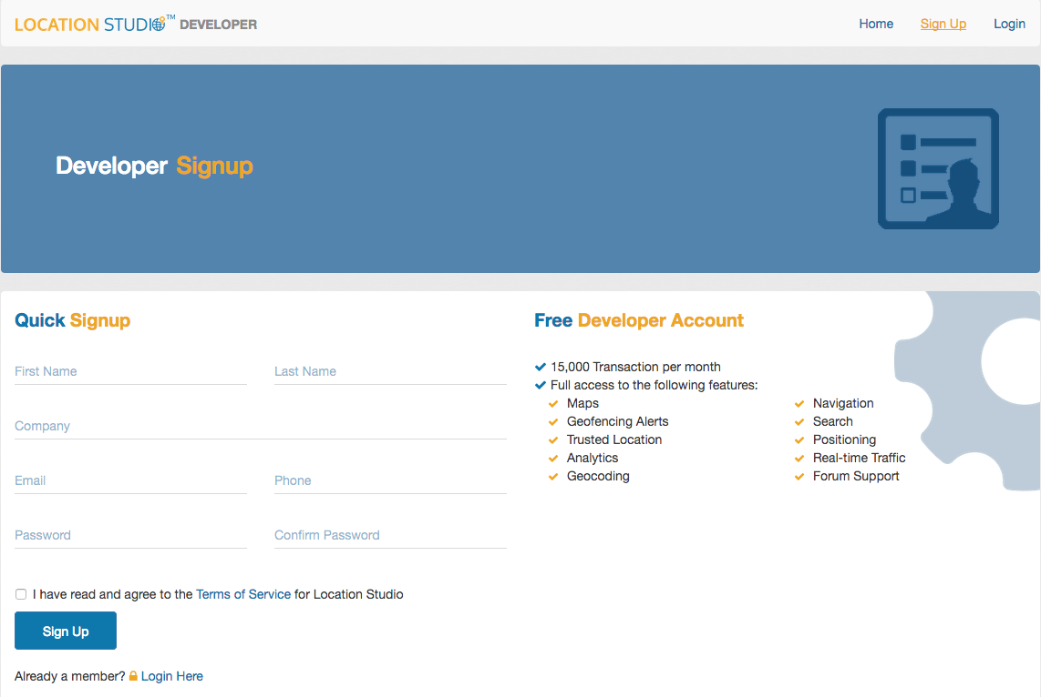

After creating the account you will get an email to verify your email address. Please Verify your email to complete account creation.

## Add an Application

Go to <https://developer.location.studio/#/applications> and click ‘Add an Application’.



## Create the API Key

Specify the name of the application, select the “Search, Navigator and Mapping” and click ‘Add’



The screen will refresh and you will now see your API key and Application name displayed.



## Enter your API key into the QML Configuration Files

The default UI for the application is based upon the Qt auto SDK. This application is found under the directory tree /opt/automotivedemo. Also available is a version of the app that conforms to the Neptune UI used by the Genivi demo platform. This version of the app may be found under the tree /opt/neptuneui.

### Adding API Key to the Qt Auto Application

You need to enter your new API key into two files in order for the reference application to be able to access the Location Studio map tiles and Search database. The files are located at the following paths:

/opt/automotivedemo/CenterConsole/apps/com.locationstudio.qtnavigator/app1.qml

/opt/automotivedemo/Cluster/qml/CenterView.qml

The contents of the ClusterView.qml are:

ClusterView {

id: map2

workFolder: "/opt/locationstudio/res/cluster"

zoom: 17.0

tilt: 15.0

isFollowMe: true // is follow me mode

token:“<YOUR_APIKEY_HERE>”

}

The contents app1.qml are:

ConsoleView {

width: 1024

height: 768

workFolder: "/opt/locationstudio/res/console"

zoom: 17

tilt: 45

isFollowMe: true

token: “<YOUR_APIKEY_HERE>”

}

### Run the Demo

$ cd /opt/automotivedemo

$ sh start.sh

### Adding API key to the Neptune (Genivi) Demo Application:

For the Neptune UI, add your API key to the files at the following location:

/opt/neptuneui/sysui/Cluster/Cluster.qml

/opt/neptuneui/sysui/Home/HomePage.qml

For Neptune, Cluster.qml is a much longer file. The relevant portion of Cluster.qml that needs to be modified with your API Key is:

ConsoleView {

property int speedLimit: RouteInfo.speedLimit

anchors.top: parent.top

anchors.left: root.leftMap ? parent.left : parent.horizontalCenter

width: root.width/1.8

//vspan: 20

height: root.height

isFollowMe: true

client: "Neptune"

workFolder: "/opt/locationstudio/res/console"

token: "<YOUR_APIKEY_HERE>"

}

HomePage.qml is a much longer file as well. The relevant portion to modify is:

ClusterView {

anchors.fill: parent

width: Style.clusterWidth - 50

//color: "#0c0c0c"

workFolder: "/opt/locationstudio/res/cluster"

token: "<YOUR_APIKEY_HERE>"

anchors.topMargin: 200

anchors.leftMargin: 500

anchors.rightMargin: 500

anchors.bottomMargin: 80

zoom: 17.0

tilt: 15.0

avatarPosition.x: -118.25 // avatar latitude

avatarPosition.y: 34.05 // avatar longitude

vatarHeading: 0.0 // avatar heading

isFollowMe: true // is follow me mode

client: "Neptune"

}

### Run the Demo

$ cd /opt/neptuneui

$ sh start.sh

### Adding API key to the Wayland Compositor Demo Application:

For the Wayland Compositor, add your API key to the files at the following location:

samples/waylandCompositorSample/demo/clusterView/resource/main.qml

For Wayland Compositor, relevant portion of main.qml that needs to be modified with your API Key is:

MapViewPlugin {

signal screenSizeChanged(double width,double height)

id: *map2*

workFolder: "/opt/locationstudio/res/cluster"

width: *root*.width

height: *root*.height

zoom: 17.0

tilt: 15.0

token: "<YOUR_APIKEY_HERE>"

}

### Build & Run the Wayland Compositor Demo

$ cd samples/waylandCompositorSample/demo/build

$ sh build.sh

$ cd ../startScript

$ sh start.sh

If you have any problems, please email our support line at [support@location.studio](mailto:support@location.studio)